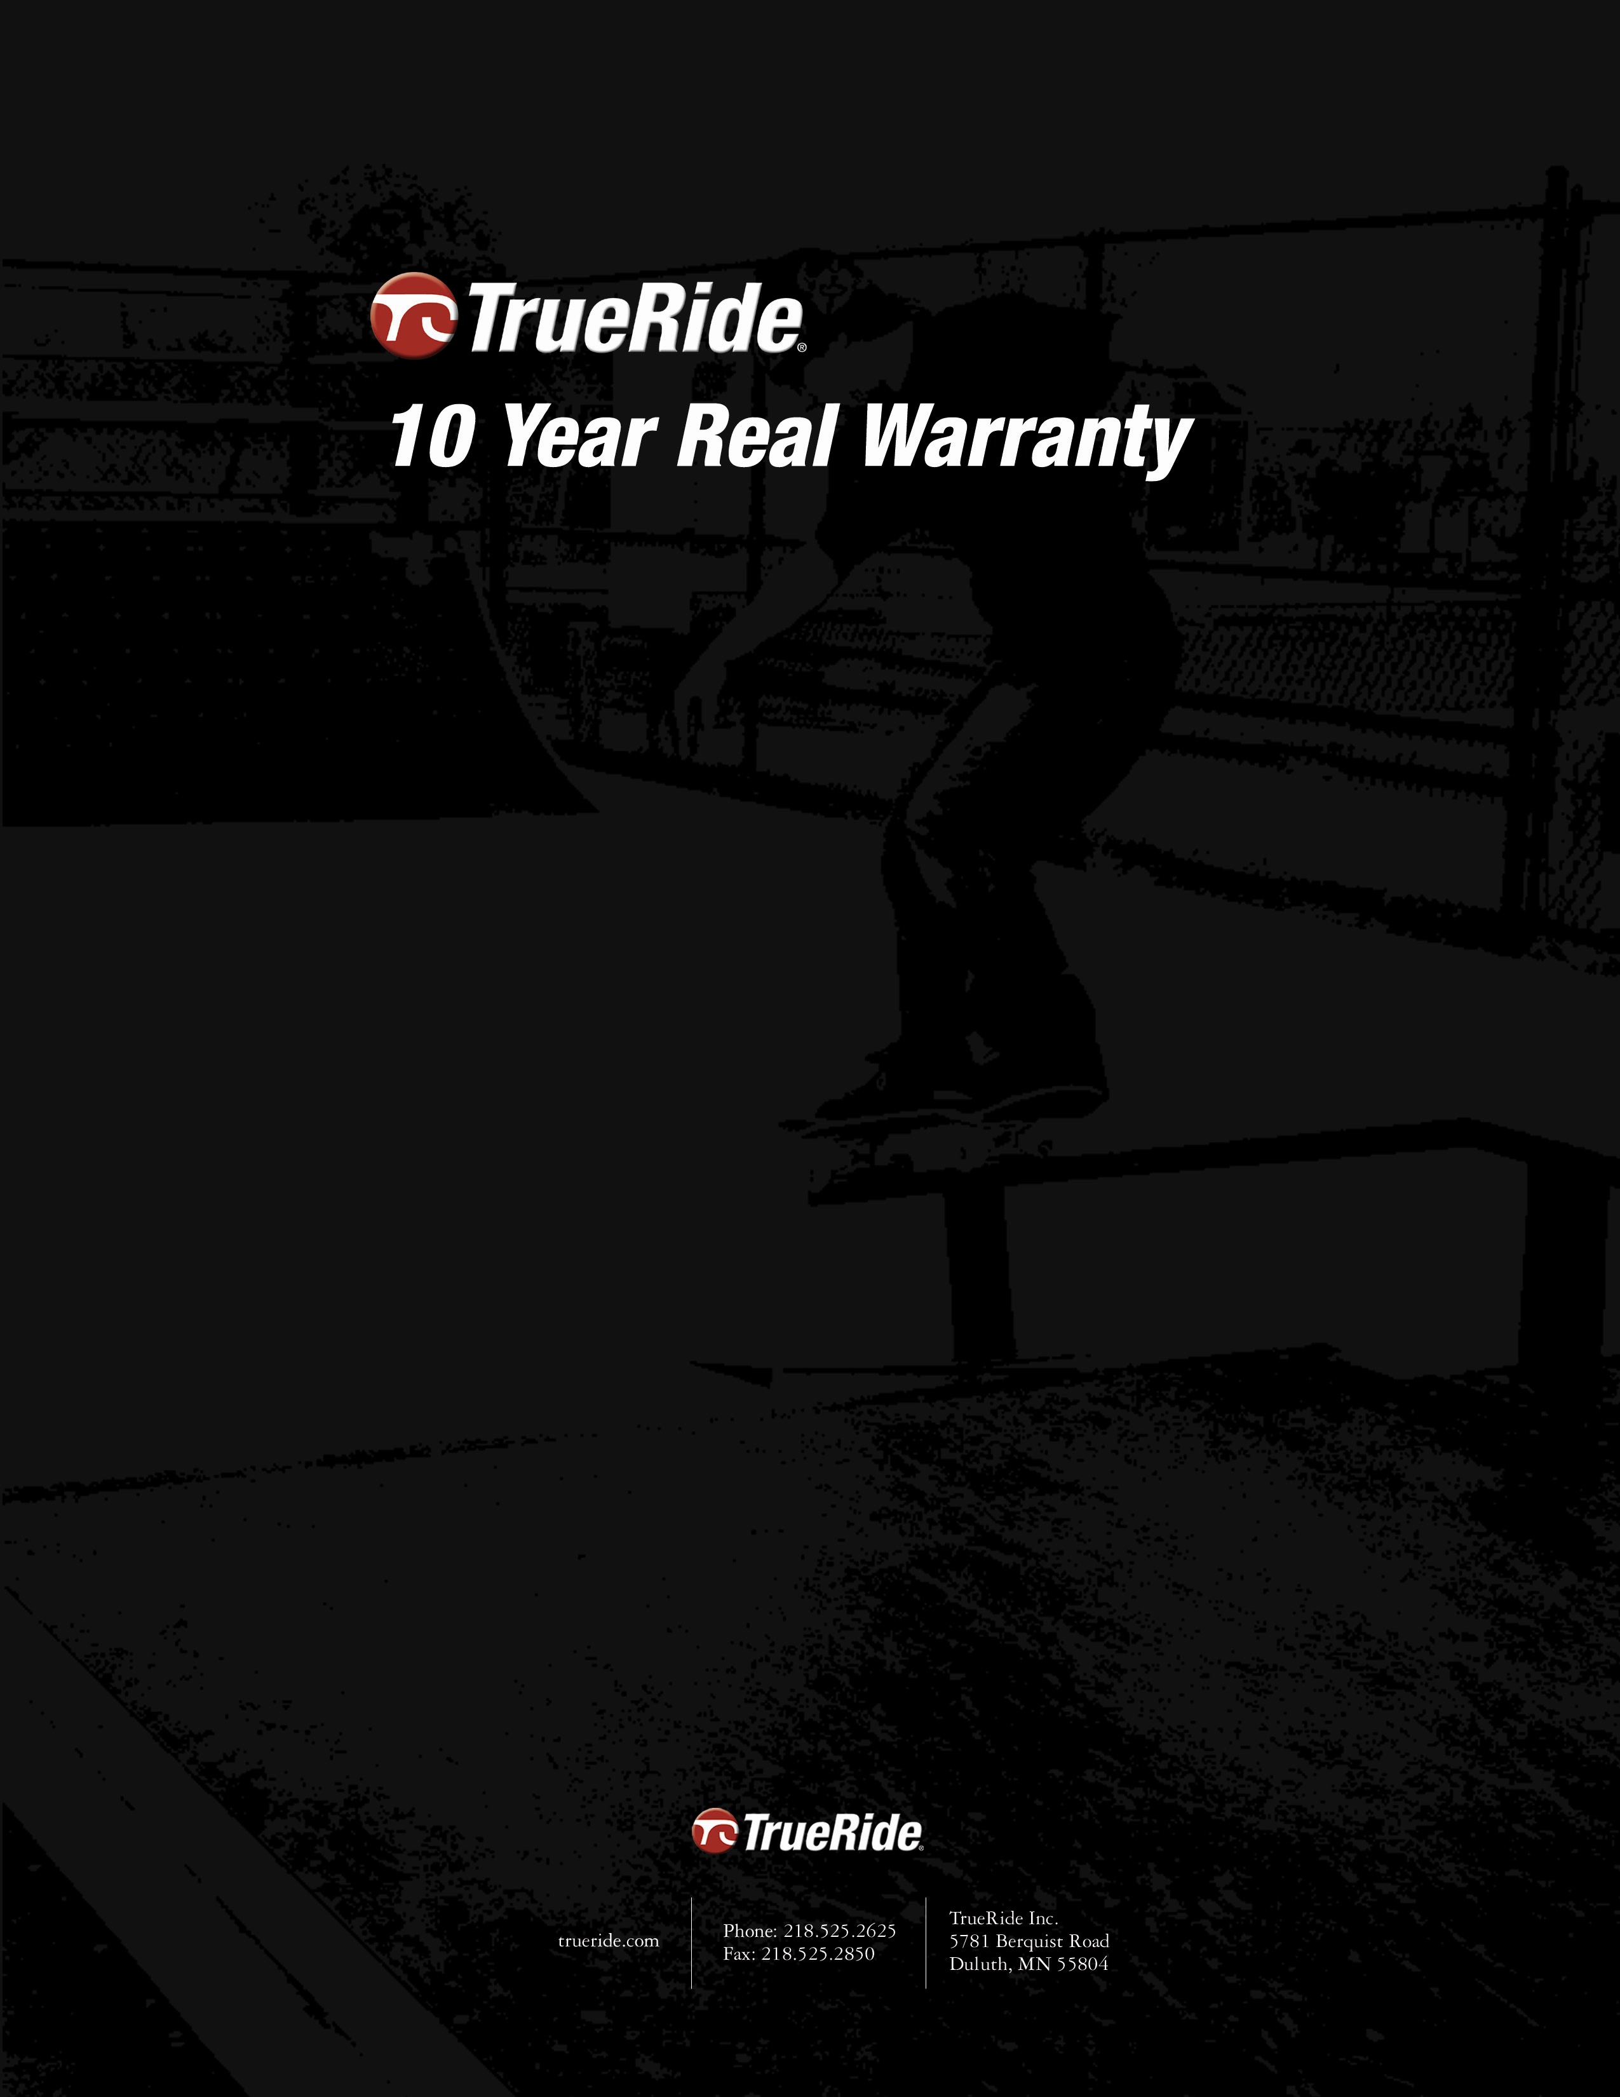

Ten Year Real Warranty

We stand beside, on top, and beneath our skate park equipment. TrueRide Inc. products are warranted against structural failure for Ten years and for five years on Skatelite skating surface from date of installation.

TrueRide Inc. products are warranted against structural failure for ten years. TrueRide Inc. will repair, without charge, any defects due to faulty materials or workmanship excluding defective or worn Skatelite skating surface.

Skatelite skating surface is warranted for five years from the date of installation. In the event of defective material TrueRide Inc. will provide the owner with replacement material free of charge for up to one year. Owner is responsible for installation of replacement of material after one year. Defective material will be replaced at no charge for up to five years from installation. (TrueRide will replace material but there will be a charge after one year.) Repair required by normal wear, neglect, abuse, accident, use of products for other than the intended purpose, and acts of nature or God are not warranted.

All steel components, other than Grinding surfaces, are also warranted for ten years. This warranty does not apply where repairs have been made or attempted by others not affiliated with or authorized by TrueRide Inc. Repair required by normal wear, neglect, abuse, accident, use of products for other than the intended purpose, and acts of nature or God are not warranted. The warranty is also void if products are assembled or disassembled by purchaser or an unauthorized party. This warranty is non transferable to another party if equipment is sold by the original purchaser.

One Year Guarantee

TrueRide certifies that all materials and workmanship are free from defects and that any repairs to your TrueRide skate park will be undertaken at TrueRide’s expense. This guarantee is good for one year from date of installation.

Insurance

TrueRide products also carry a $2 million dollar insurance policy for product liability. Our ramps are safe, solid, and dependable.



